Post Lab Validation Circular Motion

**Name _SOLUTIONS_**

A group of students conducted an experiment where a rubber stopper was whirled around in a horizontal plane, as shown below.

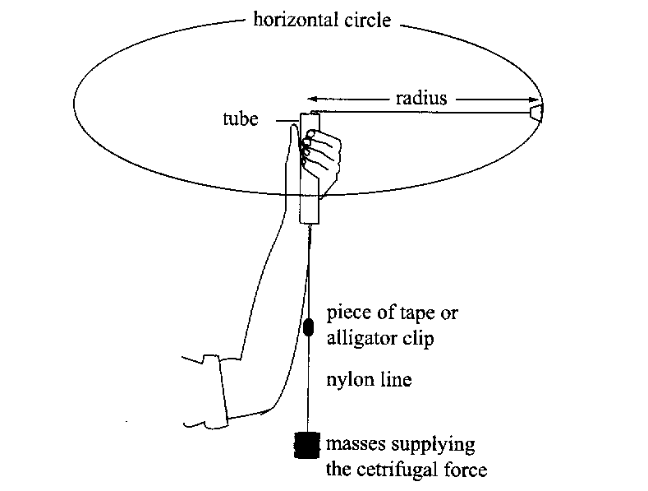

The following results were recorded.

**1)** Complete the line of data. (working space below table ) **(4 marks)**

Radius r (m) = 0.600

|  |  |  |  |  |  |  |
| --- | --- | --- | --- | --- | --- | --- |
| Mass providing centripetal force (kg) | Centripetal force (N) | Time for 20 Turns | | Average time per turn (s) | Velocity v (ms-1) | Velocity v2 (m2s-2) |
| Trial 1 (s) | Trial 2 (s) |
| 0.200 | **1.96** | 10.2 | 10.7 | **0.523** | **7.22** | **52.1** |

* 1 MARK each value correct.
* Pay follow through marks for v and v2 if incorrect time is used but only **if calculations are shown that support them**.
* Otherwise no marks

1. Assuming the students used a metre ruler with mm graduations and a stopwatch which measures to 1/10th of a second,

Calculate the % uncertainty for the velocity calculation. **(4 marks)**

Calculation involves $v = \frac{2π r}{T}$

(Calculation is a **division**, therefore must **add percentage** uncertainties.)

-- >Logic Explained  **(1)**

Calc % unc

$T =\frac{0.05}{10.45}x\frac{100}{1}$ = **0.478 %** **(1)**

$r =\frac{0.0005}{0.6}x\frac{100}{1}$ = **0.083 % (1)**

**Add together** 0.478 % + 0.083 % = 0.56% total **(1)**

**NOTE - There is no extra uncertainty added by using averages, or dividing by 10**

**3)** The students completed the experiment using a different mass but with a constant radius of 0.600 m and plotted the attached graph. Analyse their graph and data (as in your experiment) to determine the mass of the rubber stopper used. Show all necessary **calculations** and **logic**. **(4 marks)**

|  |  |
| --- | --- |
| Velocity Squared (ms-2) | Force (N) |
| 6.5 | 0.5 |
| 20 | 1.5 |
| 33.5 | 2.5 |
| 47 | 3.5 |
| 59 | 4.5 |
| 74 | 5.5 |

Logic y = m x + c

Since $F=\frac{m v^{2}}{r}$

Gradient = $\frac{m}{r}$

**Clear logic relating gradient to Equation (1)**

**Line of Best Fit** Drawn **(1)**

Calculation of Gradient **using 2 points $m=\frac{Y2-Y1}{X2-X1}$**   **(1)**

Solution approx 44.5g  **(1)**

NOTE – Using data directly from the table is NOT a valid method = ZERO

**4)** One of the major errors of this experiment is that the mass is not spinning horizontally. Briefly describe how this can affect the experiment? **(3 marks)**

**Decreased REAL radius 🡪 Means CALCULATED velocity will be higher than REAL. (1)**

**Because plotted Velocities (X Axis) will be higher than real, Gradient will be lower than real. (1)**

**Because the gradient will be lower than real, the calculated value for the mass of the stopper will also be lower than REAL (1)**

.